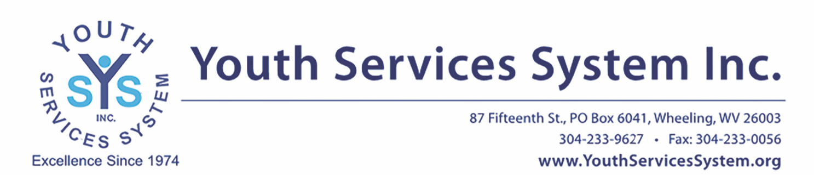
For Immediate Release
February 16, 2023
Contact: Tucker Riggleman – triggleman@ysswv.com | 304-820-9977

Youth Services System, Inc. Introduces Four New Board Members

WHEELING, W.Va — Youth Services System, Inc. is excited to welcome four new members to its volunteer Board of Directors: Amanda Bennett, Penn Kurtz, Jennifer Rohrig and David Yaeger.
Amanda Bennett is the current Director of Alumni Affairs at West Liberty University. She was born and raised in Wheeling, and graduated from John Marshall High School in 2009. Bennett earned her Bachelor’s Degree in Business Management in 2013 and her MBA in 2018, both from West Liberty University. She is a former Board Member for Harmony House, and has volunteered with the United Way of the Upper Ohio Valley and the Wheeling Soup Kitchen. Bennett has also coached for the Special Olympics and provided mentorship through the Vineyard Church and other volunteer opportunities through the area Chambers of Commerce. She currently lives in Wheeling with her fiancé Matt and their two-year old son Owen.
Penn Kurtz is a consultant for Medic Management Group LLC. He graduated from Ohio University in 1977 with a degree in Business Administration, and moved to Wheeling in 1982. Kurtz coached Women’s Basketball at Wheeling Central Catholic for 35 seasons. He also serves on the Welty Board. He has been married to his wife Jeanne for 40 years, and they have three daughters – Abbey, Julia and Molly.
Jennifer Rohrig is the Manager of Business Retention and Expansion in the Northern Panhandle for the West Virginia Department of Economic Development. She is a graduate of John Marshall High School and earned her Bachelor’s Degree in Communication from Bethany College. Rohrig also has a Master’s Degree in Strategic Communication from American University. She is a past president of the Junior League of Wheeling, a member of the Oglebay Institute Museums Committee, a member of the Moundsville Rotary, and a team captain for the American Heart Association’s annual Ohio Valley Heart Walk. Prior to her current occupation, she worked as a Partnership Specialist for the 2020 Census and as a pharmaceutical sales representative. Rohrig currently lives in Wheeling with her husband, Shawn.
David Yaeger was born in Wheeling, but raised in Chicago. He moved back to Wheeling to attend Wheeling Central Catholic High School for his junior and senior years. Yaeger graduated from West Virginia University and worked as a Bank Examiner before returning to obtain his Master’s Degree in Business. He worked in Minneapolis and St. Paul banks for 14 years before returning to the Wheeling area to be President of Farmers and Merchants Bank in Bellaire, Ohio. David worked for seven years with Progressive Bank in Wheeling before spending the remainder of his career at WesBanco. He retired from WesBanco after a career of 43 years, mostly spent in commercial lending as the Senior Vice President of Business Banking. Yaeger has three grown children who are currently following their dreams and making their own way.
The current YSS Board of Directors Officers are Rod Lee, Chair; Missy Ashmore, Vice Chair; Zak Zatezalo, Secretary; Justin Pastorius, Finance Committee Chair
Also serving on the Board are Rick Davis, Emily Freeman-Waters, Cynthia Morrison, and Matt Porter.
###

For more information about Youth Services System, Inc., visit: https://www.youthservicessystem.org/
About Youth Services System, Inc.:
Youth Services System, Inc.’s mission is “to create better futures for children, families and our community.” YSS is committed to responding to the complex needs of youth at serious risk. Since 1974, Youth Services System, Inc. has reached thousands of youth and their families with our shelter, residential, community-based and professional services. Together with youth and their families, we work to improve their physical and emotional well-being, to address the debilitating effects of abuse, substance use, and trauma, and to build the skills and connections they need to be successful. Accredited by CARF International, YSS is supported by our volunteer Board of Directors, dedicated staff and faithful community, allowing us to make a measurable impact in the lives of youth. For more information, visit www.youthservicessystem.org.

